Q1.Create a real-time chat application using Node.js, Express, Socket.io, and React/Vite.Allow users to join the application using a username and send/receive messages instantly. Store all chat messages in MongoDB so that when a user refreshes the page, previous messages are displayed.
Hints :
- User joins with username
- Send and receive messages in real-time
- Display messages in UI
- Auto-scroll to latest message
- Store messages in MongoDB
- Fetch and display previous messages on load
- Use io.on("connection"), socket.emit(), and create a MongoDB schema with timestamps.

CODE:
- App.jsx
import { useState, useRef, useEffect } from "react";
import { io } from "socket.io-client";
import "./App.css";

const socket = io("http://localhost:5000");

function App() {
const [username, setUsername] = useState("");
const [joined, setJoined] = useState(false);
const [message, setMessage] = useState("");
const [messages, setMessages] = useState([]);

const messagesEndRef = useRef(null);

// Receive real-time messages
useEffect(() => {
socket.on("receiveMessage", (newMessage) => {
setMessages((previousMessages) => [
...previousMessages,
newMessage,
]);
});

return () => {
socket.off("receiveMessage");
};
}, []);

// Fetch old messages from MongoDB
useEffect(() => {
if (!joined) return;

fetch("http://localhost:5000/messages")
.then((response) => {
if (!response.ok) {
throw new Error("Failed to fetch messages");
}

return response.json();
})
.then((data) => {
setMessages(data);
})
.catch((error) => {
console.error("Error loading messages:", error);
});
}, [joined]);

// Auto-scroll to newest message
useEffect(() => {
messagesEndRef.current?.scrollIntoView({
behavior: "smooth",
});
}, [messages]);

// Join chat
const joinChat = () => {
const name = username.trim();

if (!name) {
alert("Please enter your username");
return;
}

socket.emit("join", name);
setUsername(name);
setJoined(true);
};

// Send message
const sendMessage = () => {
const text = message.trim();

if (!text) return;

socket.emit("sendMessage", {
username,
message: text,
});

setMessage("");
};

// Send with Enter key
const handleKeyDown = (event) => {
if (event.key === "Enter") {
sendMessage();
}
};

// Get first letter of username
const getInitial = (name) => {
return name?.charAt(0).toUpperCase() || "?";
};

return (
<div className="app">

{/* ================= JOIN SCREEN ================= */}

{!joined ? (
<div className="join-screen">

<div className="join-card">

<div className="logo-circle">
💬
</div>

<h1>Real-Time Chat</h1>

<p className="join-subtitle">
Connect and chat instantly with others
</p>

<div className="input-group">
<label>Username</label>

<input
type="text"
placeholder="Enter your username"
value={username}
onChange={(event) =>
setUsername(event.target.value)
}
onKeyDown={handleKeyDown}
/>
</div>

<button
className="join-button"
onClick={joinChat}
>
Join Chat
<span>→</span>
</button>

<div className="live-info">
<span className="live-dot"></span>
Live chat • Instant messaging
</div>

</div>

</div>
) : (

/* ================= CHAT SCREEN ================= */

<div className="chat-wrapper">

{/* Header */}

<header className="chat-header">

<div className="header-left">

<div className="header-logo">
💬
</div>

<div>
<h2>Real-Time Chat</h2>

<div className="online-status">
<span className="online-dot"></span>
<span>Live • Connected</span>
</div>
</div>

</div>

<div className="user-badge">

<div className="user-avatar">
{getInitial(username)}
</div>

<div className="user-details">
<span className="user-name">
{username}
</span>

<span className="user-label">
You
</span>
</div>

</div>

</header>

{/* Messages */}

<main className="messages-container">

{messages.length === 0 ? (

<div className="empty-chat">
<div className="empty-icon">
💬
</div>

<h3>No messages yet</h3>

<p>
Start the conversation and say hello!
</p>

</div>

) : (

<div className="messages-list">

{messages.map((msg, index) => {

const isMine =
msg.username === username;

return (
<div
key={msg._id || index}
className={`message-row ${
isMine ? "mine" : "other"
}`}
>

{/* Avatar */}

{!isMine && (
<div className="message-avatar">
{getInitial(msg.username)}
</div>
)}

<div className="message-content">

<div className="message-meta">

<span className="message-username">
{isMine
? "You"
: msg.username}
</span>

{msg.createdAt && (
<span className="message-time">
{new Date(
msg.createdAt
).toLocaleTimeString([], {
hour: "2-digit",
minute: "2-digit",
})}
</span>
)}

</div>

<div className="message-bubble">
{msg.message}
</div>

</div>

</div>
);
})}

<div ref={messagesEndRef}></div>

</div>

)}

</main>

{/* Message Input */}

<footer className="message-footer">

<div className="message-input-wrapper">

<input
type="text"
placeholder="Type your message..."
value={message}
onChange={(event) =>
setMessage(event.target.value)
}
onKeyDown={handleKeyDown}
/>

<button
className="send-button"
onClick={sendMessage}
disabled={!message.trim()}
>
<span>Send</span>
<span className="send-icon">➤</span>
</button>

</div>

<div className="footer-text">
Press <b>Enter</b> to send • Messages are saved securely
</div>

</footer>

</div>
)}

</div>
);
}

export default App;

- Models/Message.js
const mongoose = require("mongoose");
const messageSchema = new mongoose.Schema(
{
username: {
type: String,
required: true,
},
message: {
type: String,
required: true,
},
},
{
timestamps: true,
}
);

module.exports = mongoose.model("Message", messageSchema);

- Server.js
const express = require("express");
const http = require("http");
const { Server } = require("socket.io");
const mongoose = require("mongoose");
const cors = require("cors");
const dotenv = require("dotenv");

const Message = require("./models/Message");

dotenv.config();

const app = express();
const server = http.createServer(app);

const io = new Server(server, {
cors: {
origin: "http://localhost:5173",
methods: ["GET", "POST"],
},
});

app.use(cors());
app.use(express.json());

// MongoDB connection
mongoose
.connect(process.env.MONGO_URI)
.then(() => {
console.log("MongoDB connected");
})
.catch((error) => {
console.error("MongoDB connection error:", error);
});

// Test route
app.get("/", (req, res) => {
res.send("Chat server is running");
});

// Get previous messages
app.get("/messages", async (req, res) => {
try {
const messages = await Message.find()
.sort({ createdAt: 1 })
.limit(100);

res.json(messages);
} catch (error) {
console.error("Error fetching messages:", error);
res.status(500).json({
error: "Failed to fetch messages",
});
}
});

// Socket.io connection
io.on("connection", (socket) => {
console.log("User connected:", socket.id);

// User joins
socket.on("join", (username) => {
socket.username = username;
console.log(`${username} joined the chat`);
});

// Receive and save message
socket.on("sendMessage", async (data) => {
try {
const newMessage = new Message({
username: data.username,
message: data.message,
});

const savedMessage = await newMessage.save();

// Send message to all connected users
io.emit("receiveMessage", savedMessage);
} catch (error) {
console.error("Error saving message:", error);
}
});

// User disconnects
socket.on("disconnect", () => {
console.log("User disconnected:", socket.id);
});
});

const PORT = process.env.PORT || 5000;

server.listen(PORT, () => {
console.log(`Server running on http://localhost:${PORT}`);
});

OUTPUT:
Introductory Screen:
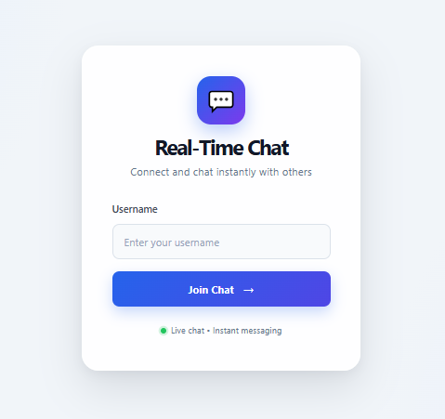
Chat UI:
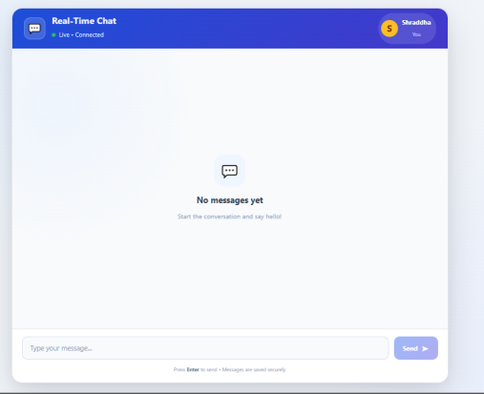
After Chat between 2 Users: Shraddha & Shrusti:
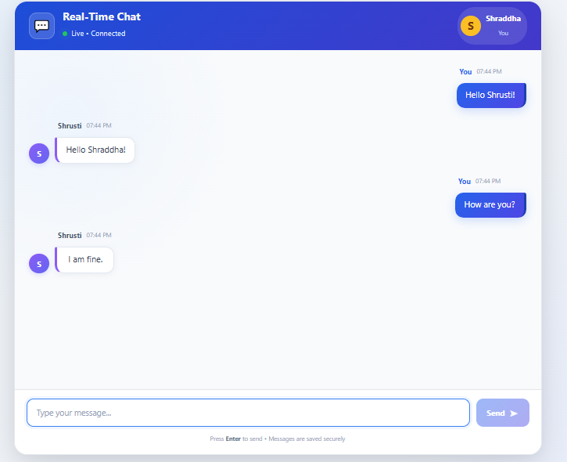
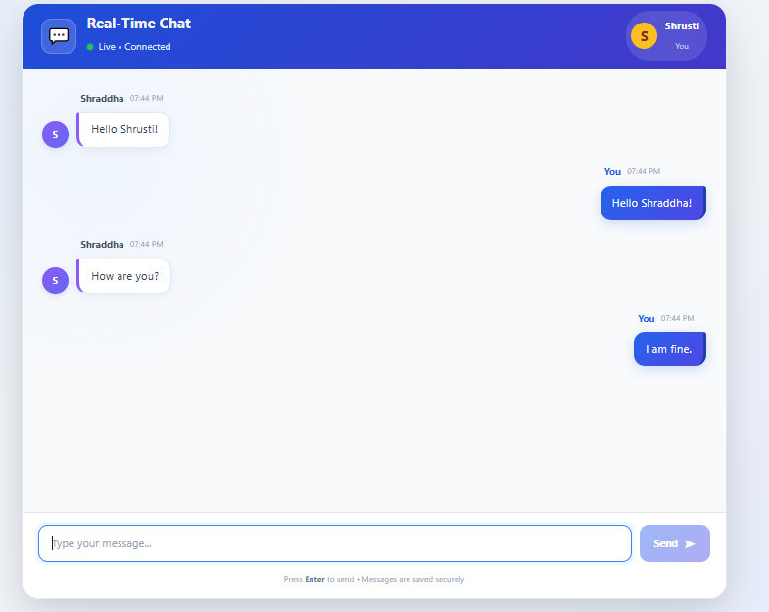
Q2.Develop a multi-room chat system using Socket.io and MongoDB.
Users should be able to join different rooms (e.g., “Cricket”, “Coding”) and communicate only within that room.
Store all messages in MongoDB with room information and load previous messages of that specific room.
Hints :
- Join a specific room
- Send messages only to that room
- Display users in each room
- Store messages with room field in MongoDB
- Fetch room-specific chat history
- Use socket.join(room) and io.to(room).emit() along with MongoDB query:
Message.find({ room })
CODE:
OUTPUT:
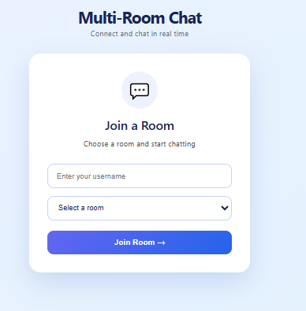
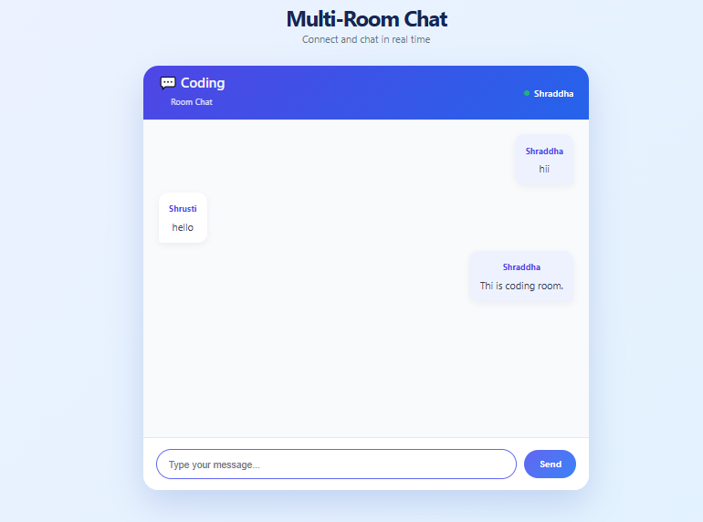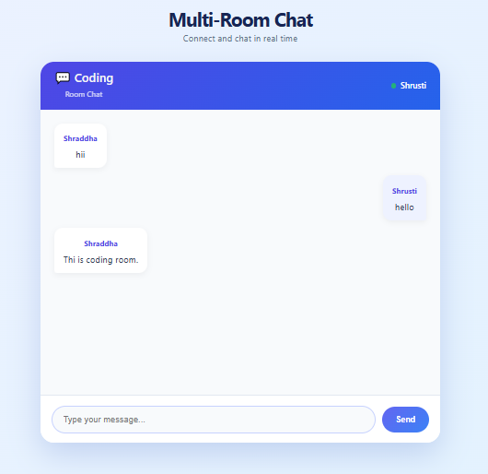
Q3.Implement a location sharing feature in the chat application using Socket.io and MongoDB.Users should be able to share their current location, which is broadcast to all users and stored in the database.
Hints :
- Button: “Send Location”
- Fetch user location using browser API
- Send latitude and longitude using Socket.io
- Display location as Google Maps link
- Store location data in MongoDB
- Load previously shared locations on refresh
- navigator.geolocation.getCurrentPosition()
Store location in MongoDB with fields: { lat, lng, createdAt }
CODE:
OUTPUT:
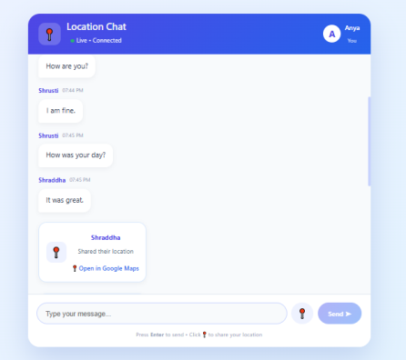
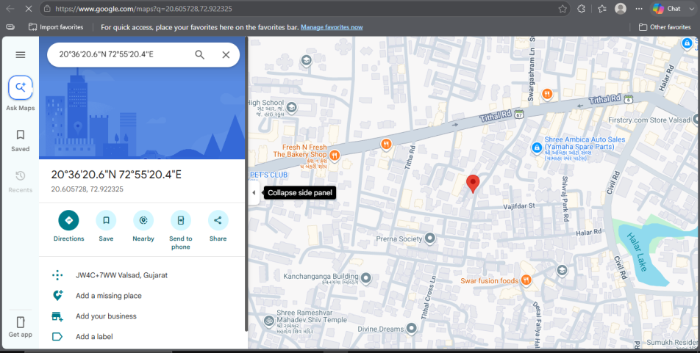
Q4.Create a message delivery acknowledgment system in the chat application using Socket.io.
When a user sends a message, display a confirmation (e.g., “Delivered”) once the server acknowledges it.
Hints :
- Use callback acknowledgment
- Show delivery status to sender
- Optionally update status in database

CODE:
OUTPUT:
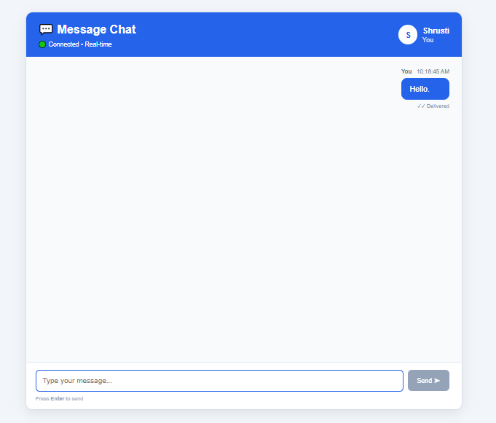
Q5.Develop a user tracking system in the chat application using Socket.io.
Track when users join or leave and display the list of active users in real-time.
Hints :
- Show “User Joined” and “User Left” messages
- Maintain and display active users list
- Update list dynamically

CODE:
OUTPUT:
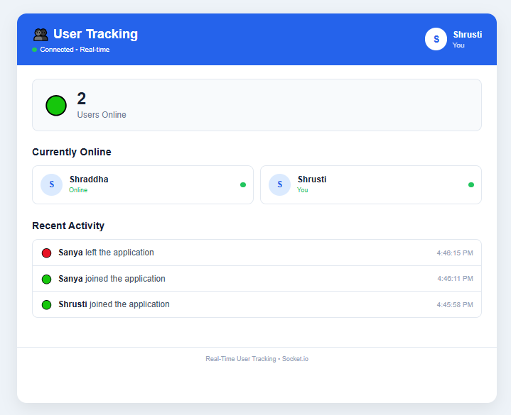
Q6.Enhance the chat application by implementing message timestamps and sorting.
Each message should display the time it was sent and messages should be ordered correctly.
Hints :
- Show message time (e.g., 10:45 AM)
- Sort messages by timestamp
- Implement “last seen” concept

CODE:
OUTPUT:
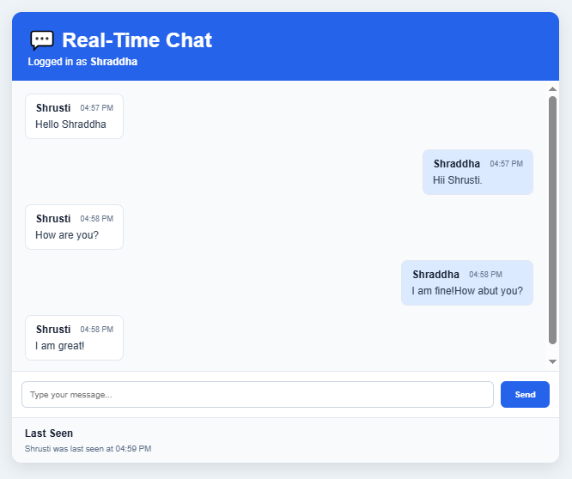
Q7.Develop an API using Node.js, Express, MongoDB, and Redis for handling chat data efficiently.Store permanent data in MongoDB and use Redis for caching frequently accessed data.
Hints :
- Create API endpoints:
/messages → return chat history
/users → return active users
- Store data in MongoDB
- Cache recent data in Redis
- Fetch from Redis first, fallback to MongoDB Use Redis commands:
SET, GET, LPUSH, LRANGE

CODE:

